Website Traffic Analysis Report
Objective -Analyze user interactions and engagement patterns using the provided dataset.
Dataset Overview
- Total Records: 226,278
- Columns: 9
- Events: Pageview, Click, Preview
Data Cleaning
- Checked missing values.
- Removed duplicate records.

Event Analysis
The distribution of user events such as pageviews, clicks, and previews was analyzed.
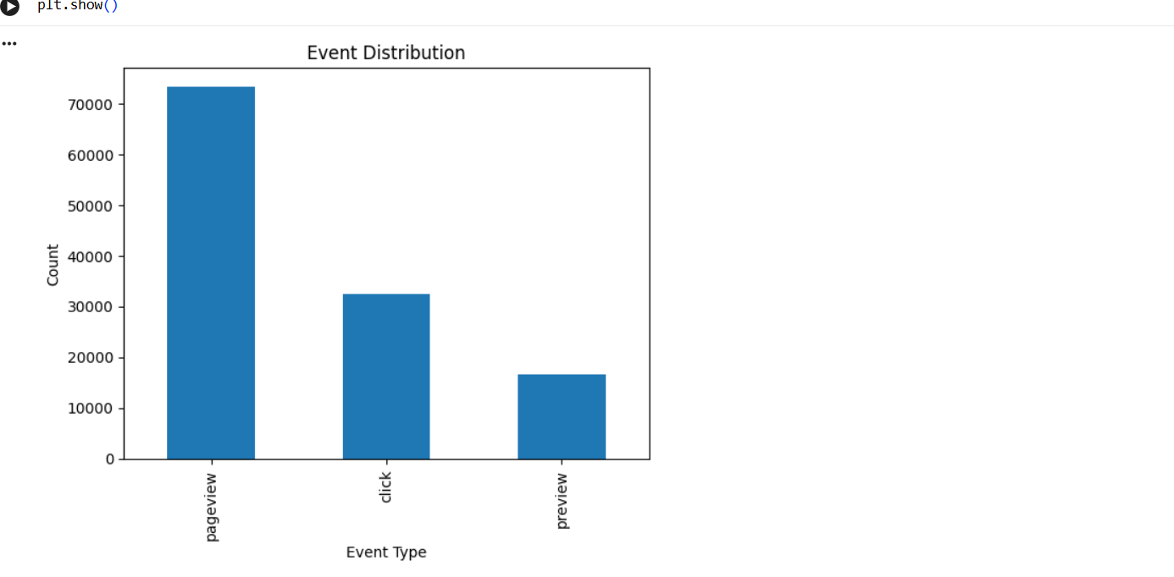
Geographic Analysis
Traffic was analyzed across different countries and cities to identify key user locations.
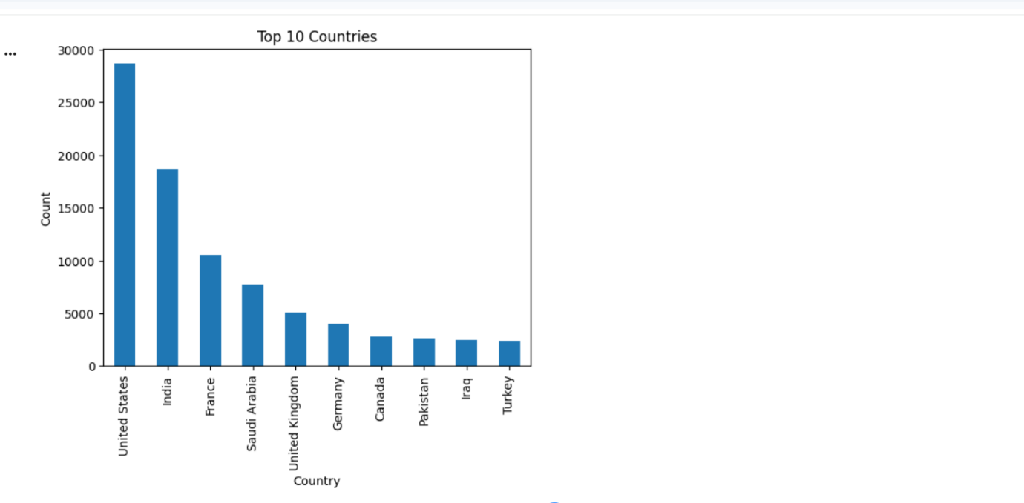
Artist Analysis
The most popular artists were identified based on user interactions.
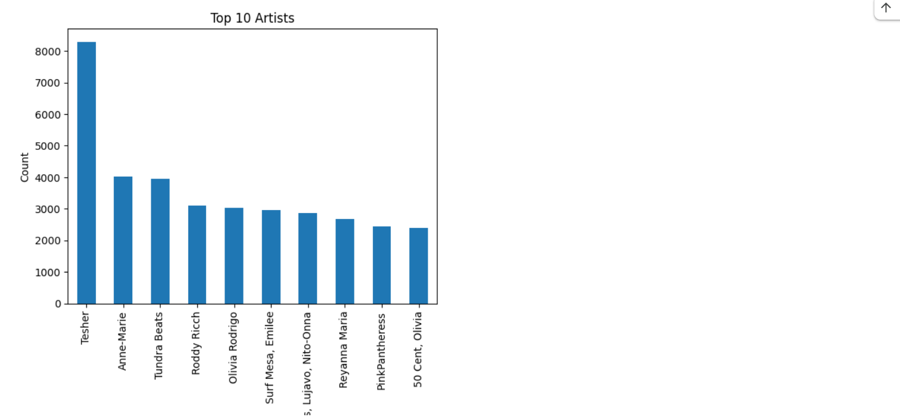
Key Findings
1. The dataset contained 226,278 records before cleaning.
2. A significant number of duplicate records were identified and removed.
3. Pageview was the most common event, indicating strong user traffic.
4. Click events represented a substantial portion of user engagement.
5. User activity was concentrated in a limited number of countries and cities.
6. Certain artists received significantly higher interaction than others.
Recommendations
1. Improve page content to increase the conversion of pageviews into clicks.
2. Focus marketing campaigns on the top-performing countries and cities.
3. Promote high-performing artists and tracks to maximize engagement.
4. Improve data quality by reducing missing metadata values.
5. Monitor user interaction trends regularly to identify growth opportunities.
Conclusion
The analysis provided insights into user interaction patterns, geographic distribution, and content popularity. After cleaning the dataset and analyzing event behavior, several opportunities were identified to improve engagement and optimize performance. The findings can support data-driven decision-making and marketing strategies.

